Top 10 Controversial Court Cases
by Cristen Conger
|
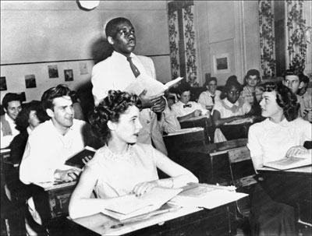
A black student, Nathaniel Steward, recites his lesson on May 21, 1954, at the Saint-Dominique school in Washington after segregation in public schools was outlawed.
STAFF/AFP/Getty Images
In 2007, the U.S. Supreme Court heard 78 cases on issues including terrorism, water rights, firearms and immigration [source: On the Docket]. As the highest court in the land, it serves as the ultimate decider in cases that can alter the law and influence society for generations to come. Take, for instance, Brown v. Board of Education of Topeka, the 1954 ruling that struck down the concept of "separate but equal" and declared racially segregated public schools unconstitutional. That decision helped spark the Civil Rights Movement, which changed the course of American history.
But landmark court decisions such as Brown v. Board are rarely met without debate. People on both sides of the aisle may disagree with a judge or jury's ruling, sometimes boiling over in violence. Although the fundamentals of the American judicial system are centered on the concepts of innocent until proven guilty, trial by jury and due process, the public may not always believe that those tenets were upheld during trials.
Are there times when the courts fail to truly resolve a problem? What happens when these legal structures create more questions than they answer? To answer that, let's take a look at some of the most controversial cases in the history of the United States. Each produced some sort of verdict, but the outcomes left many doubtful about whether justice was truly met.
Court Case 10: O.J. Simpson Murder Trial
|

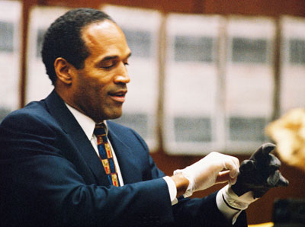
O.J. Simpson tries on a leather glove allegedly used in the murders of Nicole Brown Simpson and Ronald Goldman during testimony in his murder trial June 15, 1995, in Los Angeles.
Lee Celano/WireImage
Year: 1994
Charge: Murders of Nicole Brown and Ron Goldman
Plea: Not guilty
Verdict: Not guilty

The murder case of former Heisman Trophy winner and star NFL fullback O.J. Simpson captivated U.S. audiences for months. It began with the televised police chase of Simpson in a white Ford Bronco through Los Angeles roads on June 17, 1994.
Simpson married Nicole Brown in 1985, but the couple split in 1992. On June 11, 1994, Simpson and Brown attended their daughter's play in Los Angeles and then parted ways. Brown went to dinner with friends, and Simpson left to pack for a flight to Chicago scheduled later that night. The next morning, neighbors found Nicole Brown and her friend Ron Goldman murdered outside of Brown's Los Angeles condo.
Evidence seemed to point in Simpson's direction. For instance, the limo driver who picked Simpson up to take him to the airport the night of the murder testified that when he arrived at the house and rang the doorbell, no one answered. While waiting, the driver then saw a large black person in dark clothes enter Simpson's house. Minutes later, Simpson answered the door. Blood was also found in some of Simpson's belongings, including his white Ford Bronco and a pair of socks.
The trial began on Jan. 24, 1995, after Simpson pled not guilty to the two murders. His defense team was led by Johnnie Cochran, who turned the focus of the trial proceedings to alleged racism of the lead police detective in the case. Since the jury was majority-black, some felt that Cochran manipulated the race issue as a ploy to gain their sympathies. After more than four months of court proceedings, the jury acquitted Simpson of both counts of murder.
In light of the evidence, many questioned the jury's decision. And, in the wrongful death civil suit brought by the Brown and Goldman families soon after, Simpson was found liable.
Court Case 9: Lizzie Borden
|

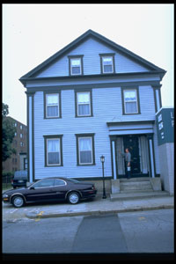
Exterior view of house where Lizzie Borden axe murders took place
Richard Howard/Time Life Pictures/ Getty Images
Year: 1893
Charge: Murders of her father and stepmother, Andrew and Abby Borden
Plea: Not guilty
Verdict: Not guilty
The Lizzie Borden case has been preserved in the public's memory through the popular rhyme:
Lizzie Borden took an axe, Gave her mother 40 whacks, When she saw what she had done, She gave her father 41.
The murder of Andrew and Abby Borden happened on Aug. 4, 1892, in Fall River, Mass. Lizzie Borden, 33 years old at the time, was arrested for the murder based on these facts: She was home alone at the time of the murders and there were no signs of a struggle.
After the trial began, the prosecution presented the infamous head of an axe that was thought to be the murder weapon. A friend of Borden's also testified to seeing her burn a dress after the crime. Borden claimed she burned the dress because it was covered in paint.
Nevertheless, the prosecution couldn’t conclusively prove that she -- and no one else -- had killed the parents. And despite rumors circulating that Borden had a bad relationship with her stepmother, witnesses in the trial testified otherwise.
After the case concluded and Borden was found not guilty, another suspect was never found.
Court Case 8: Sam Sheppard
|

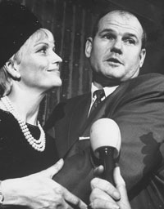
Sam Sheppard embracing his second wife during a trial for the alleged murder of his first wife
Lee Balterman//Time Life Pictures/ Getty Images
Year: 1954
Charge: Murder of Marilyn Sheppard
Plea: Not guilty
Verdict: Guilty, but later acquitted
Rumored to be the basis of the television show "The Fugitive," Sam Sheppard's trial for the murder of his pregnant wife revolved around an unknown murder weapon and questions about a possible intruder. Marilyn Sheppard was murdered in her second-floor bedroom early on the morning of July 4, 1954. Sam had reportedly fallen asleep on a daybed on the first floor and was awakened by his wife's scream.
But a shadow of doubt was soon cast over Sam when his account of events seemed somewhat unlikely. He claimed that someone had broken into the house, gone upstairs and attacked Marilyn. He said that he ran upstairs and tried to fight off the "bushy-haired intruder" but was knocked unconscious from behind. After waking up, he ran after the person and tried unsuccessfully to overtake him.
There were no signs of forced entry, and opened drawers and his overturned medical bag seemed too tidy for a random break-in. Also, Sheppard's testimony was given rather stiffly and formally. Evidence of extramarital affairs capped off the prosecution's case.
The jury found Sheppard guilty of second-degree murder with life imprisonment. But because of how much media attention the case attracted, Sheppard was eventually retried in 1966, where he was acquitted. Interestingly, a civil suit for wrongful imprisonment filed by Sheppard's son and tried in 2000 found Sheppard liable.
Court Case 7: Scopes Monkey Trial
|
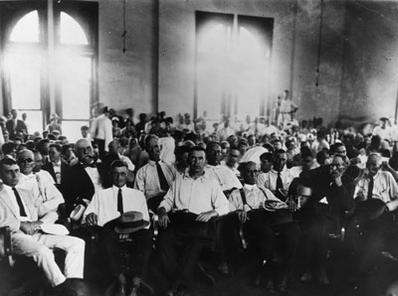
Jury in the Scopes trial
Hulton Archive/Getty Images
Year: 1925
Charge: Illegal teaching of evolution
Plea: Not guilty
Verdict: Guilty
The outcome of the Scopes Monkey Trial resonates in U.S. education even today. In 1925, in Dayton, Tenn., high school teacher John Scopes went to court for teaching the theory of evolution to his students. The state's constitution banned the subject in schools. But Scopes served as more of a pawn; the true purpose of the case was to formally debate the evolution ban in court and to address the controversy surrounding it.
The prosecution team was led by William Jennings Bryan, a former presidential candidate and staunch opponent of evolution. On Scopes' side, Clarence Darrow aimed to prove that the state ban was unconstitutional. Bryan and Darrow attracted crowds of thousands during the hearings. The testimonies and their statements weighed the validity of Darwin's theory versus that of the Bible.
Ultimately, Darrow, on behalf of the defense, requested that the jury find Scopes guilty so that the case could continue to the state Supreme Court, where the constitutional ban could be possibly overturned. The jury did so, and the Tennessee Supreme Court eventually dismissed the case.
Court Case 6: John Hinckley Jr.
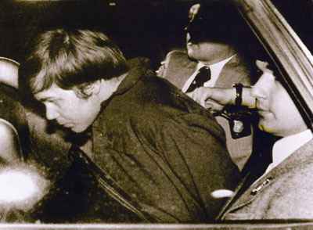
John Hinckley Jr. (L) escorted by police in Washington, D.C. on March 30, 1981, following his arrest after shooting and seriously wounding then U.S. president Ronald Reagan.
AFP/Getty Images
Year: 1982
Charge: Attempted assassination of President Ronald Reagan
Plea: Insanity
Verdict: Not guilty by reason of insanity
On March 30, 1981, John Hinckley Jr. opened fire on President Ronald Reagan outside of the Park Central Hotel in Washington, D.C. One bullet barely missed the president's heart. Hinckley was wrestled to the ground by Secret Service agents.
But Hinckley wasn't a political vigilante. Rather, he was trying to win the heart of actress Jodie Foster, with whom he'd become obsessed after seeing the 1976 film "Taxi Driver."
After moving to New Haven, Conn., where Foster attended Yale University, leaving multiple letters and speaking with her twice to no avail, Hinckley grew more desperate. Hours before the assassination attempt, he wrote her a note detailing his plot to kill President Reagan to prove himself to her.
Hinckley's defense team set out to prove his insanity, bringing in Hinckley's psychiatrist and other mental health experts to confirm schizophrenia. The prosecution, however, brought in their own experts, testifying that he was sane enough to plan and carry out the detailed plot.
The jury's verdict of not guilty by reason of insanity enraged many Americans. An often cited ABC News poll taken the day after the verdict was announced revealed that three-quarters of people interviewed disagreed with the jury's decision [source: Finckel]. Hinckley was then transferred to St. Elizabeth's Hospital and in 2003 was allowed to have unsupervised visits with his family.
Court Case 5: The Lindbergh Baby Kidnapping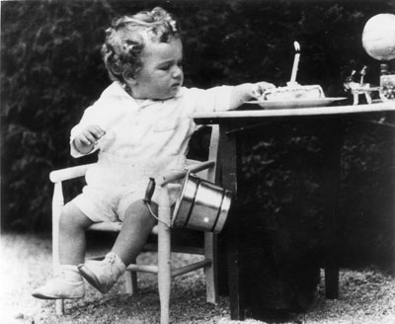

Charles Augustus Lindbergh Jr., son of the American aviator, on his first birthday
BIPS/Getty Images
Year: 1933
Charge: Murder of Charles Augustus Lindbergh Jr.
Plea: Not Guilty
Verdict: Guilty
When the infant son of famed aviator Charles Lindbergh was kidnapped from his crib around 9 p.m. on March 3, 1932, people across the nation took notice. A ransom note for $50,000 was left in baby Charles' nursery, and a broken ladder was found outside of the window.
Because of the extensive media attention, Lindbergh allowed a mediator, Dr. John Condon, to negotiate with the kidnapper. After a series of five notes, Condon met with the kidnapper and gave him $50,000 for information. Condon was told that the baby could be found on a boat off the New York harbor. But an extensive search revealed neither the boat nor baby Charles.
Then, on May 12, the baby's body was accidentally discovered in woods near the Lindbergh home. As the search for the kidnapper continued, it focused on tracking any ransom money that had been spent. Investigators traced it to Bruno Richard Hauptmann, who was arrested after authorities found thousands more at his house.
A jury found Hauptmann guilty on Feb. 13, 1933. In spite of offers to commute his sentence and monetary help for his wife and son, Hauptmann never confessed and was electrocuted on April 3, 1936.

Court Case 4: Leo Frank
|
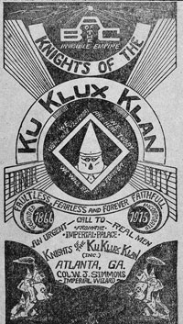
Illustrated cover of a brochure promoting a chapter of the KKK circa 1916.
Hulton Archive/Getty Images
Year: 1913
Charge: Murder of Mary Phagan
Plea: Not guilty
Verdict: Guilty
Set against the southern backdrop of Marietta, Ga., Leo Frank, a Jewish man, was accused of murdering Mary Phagan, a young white woman who worked with him in a pencil factory. The prosecution's arguments hinged on the testimony of a black janitor at the factory named James Conley. Conley said that Frank had killed Phagan and told Conley to dispose of the body. He also said that Frank had planted notes by the body blaming a black person for the crime.
Crowds inside of the courtrooms continually hurled Jewish insults during the proceedings, underlining the hatred that resonated during that era. The white supremacist group the Klu Klux Klan even formed the Knights of Mary Phagan in response.
Despite forensic evidence pointing to Frank's innocence, he was nonetheless convicted to death by hanging. As a result of the shaky evidence, the governor of Georgia commuted the sentence to life imprisonment. Subsequently, an angry mob kidnapped Frank from jail with little resistance and killed him by lynching.
In 1986, the Georgia State Board of Paroles pardoned Frank.
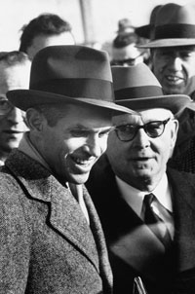
Court Case 3: Alger Hiss (left) on release from Lewisburg Prison
Ralph Morse/Time Life Pictures/ Getty Images
Year: 1949
Charge: Perjury
Plea: Not guilty
Conviction: Guilty
The Alger Hiss perjury case launched the career of then-congressman Richard Nixon, the head of the House Un-American Activities Committee (HUAC) that investigated potential Communist infiltration in the government.
Hiss worked for the State Department and was accused by former Communist Whitaker Chambers of being a Soviet agent. On Aug. 5, 1948, Hiss adamantly denied the charge before HUAC.
After Hiss filed a slander suit against Chambers, Chambers produced a packet of typewritten and handwritten notes allegedly from Hiss, and later, strips of 35-mm film of State documents allegedly taken by Hiss. These were famously referred to as the "pumpkin papers" because Chambers had kept them in a hollowed-out pumpkin. As a result, Hiss was charged with perjury, or lying to the court while under oath.
Hiss later admitted to writing the handwritten notes, but the source of the film and the typewritten letters remained contentious. After one jury could not come to a verdict agreement, a second case was mounted that eventually found Hiss guilty and sentenced him to five years in prison. Hiss maintained his innocence until his death.
Court Case 2:
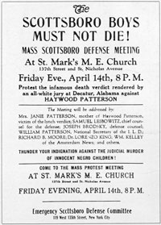
1931: A poster advertising a defense meeting for Haywood Patterson, one of the Scottsboro Boys.
MPI/Getty Images
Year: 1931
Charge: Assault and rape
Plea: Not guilty
Verdict: Guilty
The Scottsboro Boys Trial represents one of American history's darkest chapters. Nine young black men ranging in ages from 13 to 20 years old were arrested on March 25, 1931, for assault charges resulting from a fight that broke out on a freight train in Paint Rock, Ala. Two white women on the train -- Victoria Price and Ruby Bates (who later confessed that she lied) -- also claimed rape by the group of men.
Once the boys were taken into police custody in Scottsboro, Ala., the white community rioted outside of the jail, calling for punishment. Within five days, on March 30, the boys were indicted by a grand jury. By April 9, all but the youngest of the group had been sentenced to death by all-white juries.
The case moved to the Alabama Supreme Court in 1932, which upheld the previous convictions. Then, the U.S. Supreme Court heard the case, ruling that the defendants' rights had not been upheld, which sent the case back for retrial.
After three trials and six years in prison, the charges were dropped for four of the boys: Willie Roberson, Olen Montgomery, Eugene Williams and Roy Wright. The other five -- Charles Weems, Ozie Powell, Clarence Norris, Andy Wright and Haywood Patterson -- remained in prison and were eventually released on parole years later.
Court Case 1:
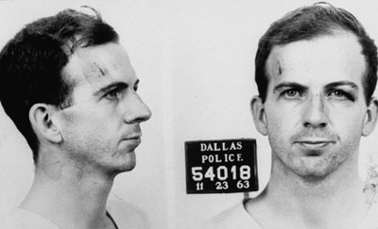
Police file photograph of Lee Harvey Oswald
Donald Uhrbrock/Time Life Pictures/Getty Images
Year: 1963
People involved: Lee Harvey Oswald and Jack Ruby
Charges: Assassination of JFK (Oswald); murder of Oswald (Ruby)
Verdict: Guilty, later overturned (Ruby)
Most agree that the trials and investigations surrounding the assassination of President John F. Kennedy in Dallas, Texas, are the most controversial in American history. The president was shot three times on Nov. 22, 1963.
Lee Harvey Oswald was arrested for the assassination after investigators discovered a rifle hidden between two boxes with Oswald's fingerprints on them, along with empty cartridges in the Texas Book Depository. Two days later, Jack Ruby shot and killed Oswald.
On March 14, 1964, Ruby was sentenced to death by electric chair for Oswald's murder. But the Texas Supreme Court overturned the ruling on the basis that the case's publicity obstructed Ruby's right to a fair hearing. Before he could be tried a second time, Ruby died from cancer in 1967.
Despite the work of the Warren Commission and the House Select Committee on Assassinations tasked with investigating the assassination, no conclusions to the reasons and people behind it have ever been found. It is suspected that Oswald acted as part of a conspiracy, and his relationship with Ruby also remains in question.

