What’s The New Definition of Power Dressing for Women?
by Meredith Lepore
|
January 15, 2013
|6

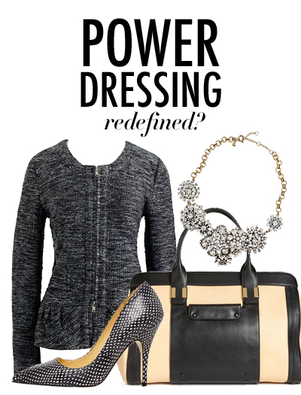
In a recent interview, fashion legend Giorgio Armani made a very bold statement. He said women no longer need to wear powerful-looking clothes in order to earn respect from their peers in the workplace. “[Women] have edged out their standing in the world. Today, they don’t have to wear a suit jacket to prove their authority.” This is pretty extraordinary considering this is a man who made the power suit for women a fashion staple. But is he right? Have women come so far that they don’t need to wear clothes to show they are powerful? Is the era of power dressing over? Or maybe women used to have wear certain clothes to show they were powerful and now they just wear clothing that gives them a little extra confidence.

According to The Wall Street Journal, the old-fashioned power suit look for professional women is actually dead (think Sigourney Weaver and Melanie Griffith in Working Girl with the giant shoulder pads.) Women can now wear soft colors (even pink!), beading, prints, patterns and have feminine tailoring (peplum is all the rage right now)—all of which were once considered taboo in the workplace for women.

There has been a shift in what is considered appropriate for women in the workplace. It has moved away from women trying to fit into the stiff, male-influenced power suit. Christina Binkley of The Wall Street Journal wrote, “The matched crimson suit—once deemed essential for a female executive—reflected an era when women tried, often clumsily, to fit into male molds. There was also a militant element to that office apparel.” She wrote of her days at Procter & Gamble in the 1980s when she was informed by a boss that only the “secretaries” wore dresses.
We are seeing this fashion shift being sported by women at the executive level who have the confidence to embrace a more integrated and diverse look. It is happening because there are just more women in these top positions and they are determining what is an appropriate look for the office.
In a recent issue of The Hollywood Reporter, female executives in the Hollywood talked about the evolution of power dressing. It used to be all about the power suit but now more fashionable and feminine items are considered just as powerful. “When I got to town in 1989,” says Blair Kohan, now a fashionably dressed partner at UTA, “everybody was wearing these suits. I had one from Ann Taylor. You didn’t get Armani until you got to the top. I see more expressiveness. Women no longer have to look tough because we are tough.”

Armani did add that fashion can still be used to boost confidence and what woman doesn’t agree that having a great top or a great pair of heels can give you a little more oomph in your step (if you are good at walking in heels that is)? Studies have even shown that wearing high heels and (the right amount of makeup) can help women come off as more competent. A recent survey from The Daily Telegraph found that two out of five women surveyed believed wearing something red increased professional confidence. ”The clothes and colors we wear have a real impact on the way we feel. The colour red is associated with confidence and power,” Dr. Gayle Brewer, who conducted the study, told the British newspaper. One in 10 women polled said they would wear red to impress in the office, while 26 percent said even a touch of red lipstick boosted their confidence.
There are definitely still power items that every woman should have in her work wardrobe but we don’t need to count on giant shoulder pads and binding pencil skirts to show the boss that we can keep up with the boys. Women can now wear flowers at work and still project power and that is a great thing.

