On a School Rooftop, Hydroponic Greens for Little Gardeners
By KERRI MACDONALD
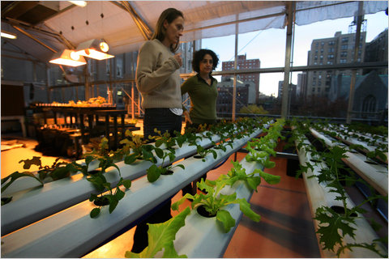Nicole Bengiveno/The New York Times Sidsel Robards, left, and Manuela Zamora, founders of the greenhouse atop the Manhattan School for Children.
Shakira Castronovo stood in a classroom at the Manhattan School for Children on West 93rd Street on a recent afternoon and hushed a squirming group of kindergartners perched around a blue carpet.
“Where do you think I picked this?” she asked, pinching a leafy-looking thing between her index finger and thumb. “It was picked fresh just few minutes ago.”
Someone wondered if it had come from the recess yard. Maybe from a farmers market? A minute later, a little girl in pink came up with the answer. “Greenhouse!” she shrieked as her hand shot into the air.
“This is called mizuna,” Ms. Castronovo said, enunciating the new word. “And we are finally ready to harvest some of our lettuces.”
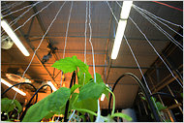Nicole Bengiveno/The New York Times Final touches are being added to the greenhouse.
Mizuna? “It’s the kind of thing that adults put with other lettuces when they have a salad,” she explained. “But you can still take a nibble.”
The grown-up lettuce came from what its founders say is the first hydroponic laboratory greenhouse on a New York City public school roof. The garden will officially open Dec. 6. But plants are already sprouting, making their way into classrooms.
There’s no soil in a hydroponic greenhouse, which captures and recirculates rainwater to the roots of plants. In capable hands — though maybe not in 5-year-old hands — the 1,400-square-foot structure can produce up to 8,000 pounds of vegetables every year. It is an experiment in environmental education its founders hope will be replicated in schools citywide.
Two mothers at the school, Sidsel Robards and Manuela Zamora, founded the greenhouse, inspired in 2008 by a trip to the Science Barge, a floating urban farm docked in Yonkers. They got New York Sun Works, the nonprofit green-design group that built the barge, interested enough to execute the greenhouse, a bright, open and wheelchair-accessible space, covered by glass and entered from the school’s third floor, that is essentially the Barge on a roof.
It includes a rainwater catchment system, a weather station, a sustainable air conditioner made of cardboard, a worm-composting center and solar panels. In the center of the room is a system resembling a plant-filled hot tub: an aquaponics system home to a community of tilapia, whose waste is converted into nitrate. The system loses water only when it evaporates to help cool plants, consuming only a tiny fraction of the water that a field of conventional dirt does.
“You basically can have this closed system, this symbiotic thing going on, where plants are eating food, creating waste, you’re converting it and then the plants are taking it up,” said Zak Adams, director of ecological design at BrightFarm Systems, which designed the greenhouse and the barge.
Including everything from permits to teacher training, the project cost about $800,000, most of which came from outside the school community. City Councilwoman Gale A. Brewer and the Manhattan borough president, Scott M. Stringer, provided grants.
Ms. Robards and Ms. Zamora, working in partnership with New York Sun Works, hope to spread the gospel of hydroponic farming to other city schools and are working to build a greenhouse at Public School 89 in Cypress Hills, Brooklyn.
The food produced at the Manhattan School will probably go to a farm stand in the lobby, a nearby shelter or to cooking projects in the classroom and cafeteria. But its founders are careful not to think of it as a bona fide food production system.
“It’s important to remember that it’s a science lab and we want the kids to be able to fail, too,” Ms. Robards said.
At its heart, the project is about making science both accessible and exciting “in a natural way,” said Ms. Castronovo, the school’s science teacher. Explosions always grab attention. But how many kids voluntarily eat something weird and green and leafy? (“We really, really, really loved the leaf,” one kindergartner said near the end of the mizuna lesson.)
In the summer, the center will be used for teacher training programs. But during the school year, it is Ms. Castronovo’s classroom. When the kids get inside, she said, she plans to lead scavenger hunts to help familiarize them with the room.
“I want it to be a place that they respect,” Ms. Castronovo said, “but I also want it to be their home.”

