Cockroaches, Sponges and Snakes: The Top 10 New Species
May 23, 20133 Comments
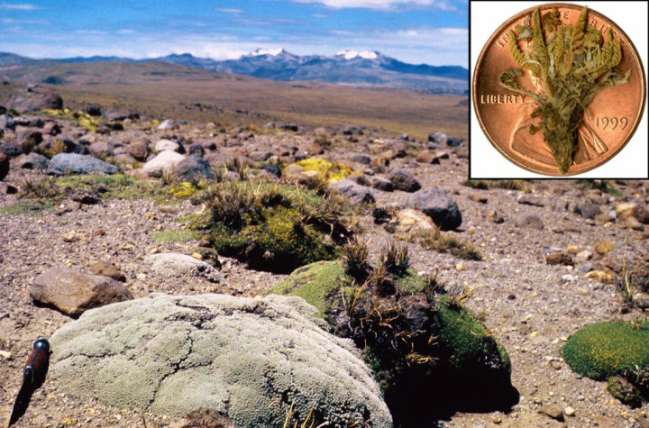
Hugh H. Iltis, Plant: Harvey Ballard
The diminutive Lilliputian violet is one of the smallest such lowers in the world, and is found in one tiny area of the high Andes in Peru. It is less than half an inch tall.
So the news we report at Ecocentric is often of the doomy sort: overfishing, extinct species, killer heat waves, deadly disasters, that sort of thing. You can’t put all the blame on us–the world really is that unstable, and at the same time, the darkest posts do seem to get the most clicks.
But not everything is bad! We live in what is still an incredible and beautiful world, one we’re only beginning to comprehend. By some counts there are perhaps 10 to 12 million separate species of plants and animals on Earth, which is about 10 to 12 million more than we know of on any other planet in this universe. And even that figure is just an estimate—we’ve only formally described perhaps 2 million species altogether. There’s a whole world of biodiversity out there waiting to be discovered by scientists willing to do the field work.
So it makes sense that’d we celebrate the 2013 list of the top 10 new species, which is put out each year by the International Institute for Species Exploration at Arizona State University. A global committee of taxonomists—the hard-noses scientists who name and classify species—assemble the list and release it on May 23, the birthday of the great 18th century Swedish botanist Carolus Linnaeus, the man responsible for the modern system of species classification.
The committee picked the top 10—which includes a glow-in-the-dark cockroach and the smallest vertebrate on Earth—from more than 140 nominated species. But this is just the beginning—the institute is calling for a “NASA-like mission” to discover 10 million new species over the next half century. We’re up against the clock, as Quentin Wheeler, the founding director of the institute, put it in a statement:
For decades, we have averaged 18,000 species discoveries per year which seemed reasonable before the biodiversity crisis. Now, knowing that millions of species may not survive the 21st century, it is time to pick up the pace.
These new species represent a good start, but there’s so much more to learn.
prev
2 of 11
next
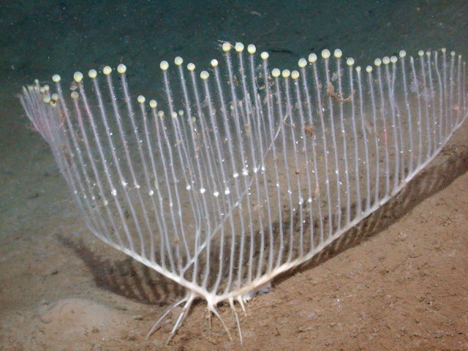
MBARI
A carnivorous sponge! Found in the deep water of the northeast Pacific Ocean, off the coast of California, the Lyre sponge uses more than 20 parallel branches to capture its planktonic prey.
prev
3 of 11
next
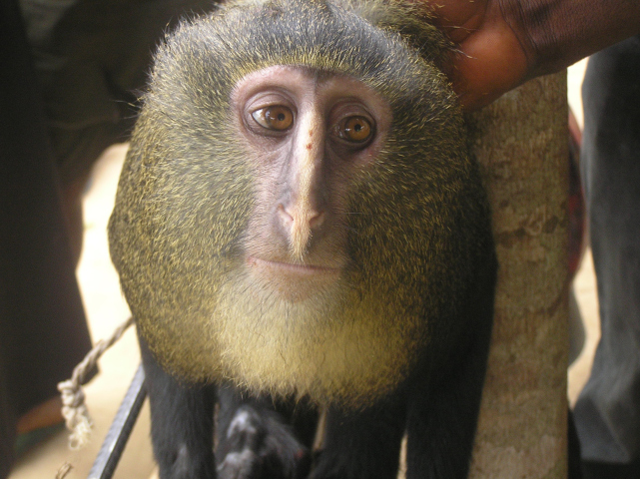
Maurice Emetshu
An Old World monkey discovered in the Lomami Basin of the Democratic Republic of the Congo in Central Africa, the lesula monkey is well known to locals but less so to sicentists. It's known for having human-like eyes, and it is hunted in the bush for its meat.
prev
4 of 11
next
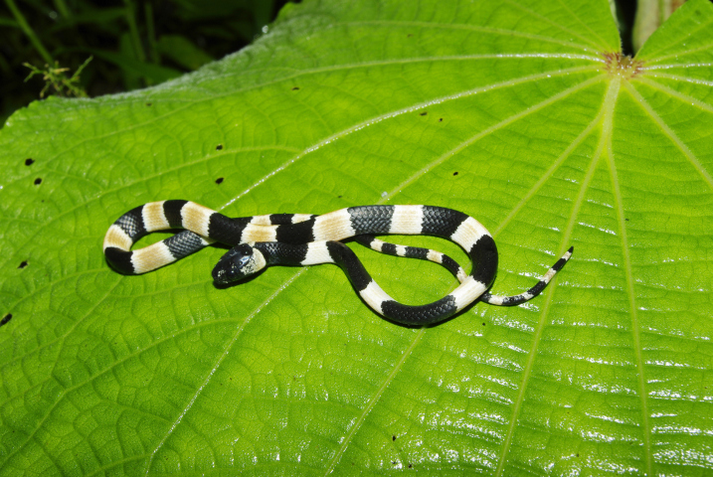
Sevastian Lotzkat
The name of this new species of snail-eating snake from Panama derives from the Spanish phrase "No a la mina." The Serrania de Tabasara mountain range where the snake lives is under threat from uncontrolled mining.
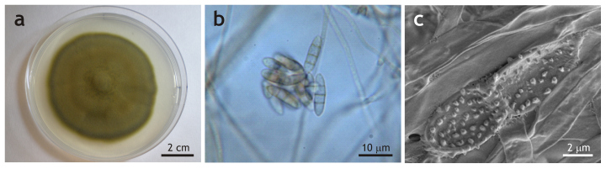
Pedro M. Martin-Sanchez
There's a fungus among this list. In 2001, black stains began to appear on the walls of the famed Lascaux Cave in France, home to ancient cave paintings. Fortunately the new species is mostly harmless, but it did have to be removed to avoid damage to the cave art.
ay 23, 20133 Comments
prev
6 of 11
next
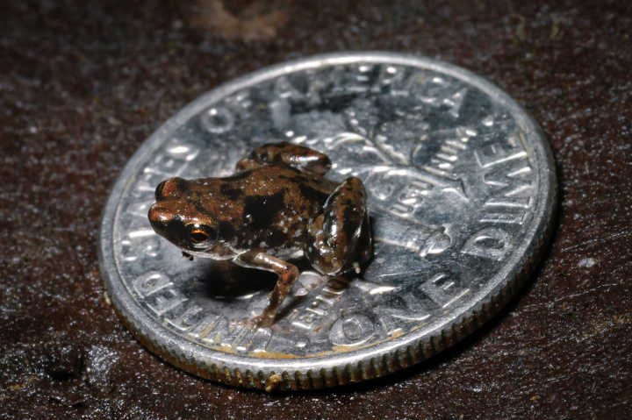
Christopher C. Austin
How small is this tiny frog? The photo here show a new species of frog sitting on a dime. It's less than 7 mm long, which makes it the smallest animal with a backbone in the world. (The largest, for the record, is the blue whale.) It's found in the moist forests of Papua New Guinea.
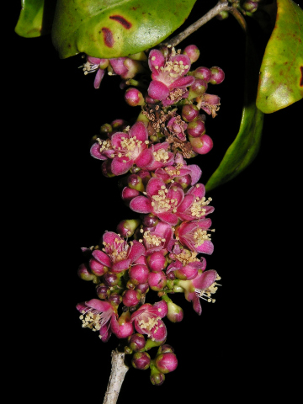
David Rabehevitra
Madagascar is home to more unique species for its size than any other place on the planet. Count a new one: the Eugenia shrub, a six-ft. high plant found in the forests of eastern Madagascar.
prev
8 of 11
next
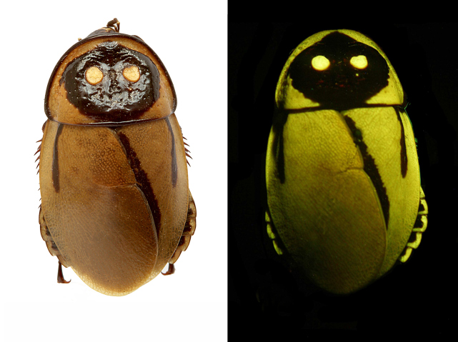
Peter Vrsansky & Dusan Chorvat
A light-mimicking roach, the Luchihormetica luckae is found in Ecuador. But it is already critically endangered, thanks to destruction caused by a volcanic eruption near its habitat.
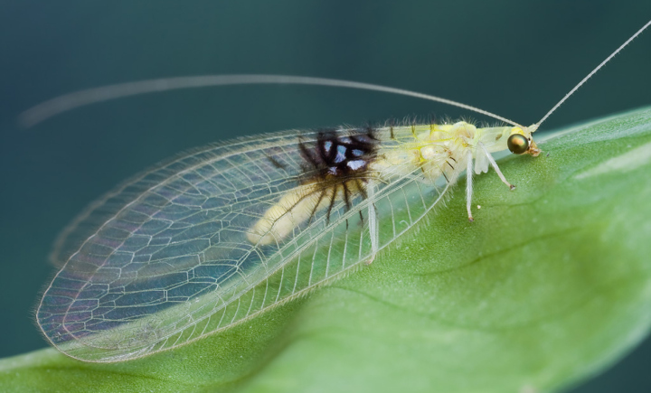
Guek Hock Ping
Found in Malaysia, this lacewing was first photographed by a Malaysian man who uploaded the images to Flickr. From there it was seen by an entomologist in California who noticed it was unusual, and arranged for a specimen to be sent to London.The result: a citizen science discovered new species.
23, 20133 Comments
prev
10 of 11
next
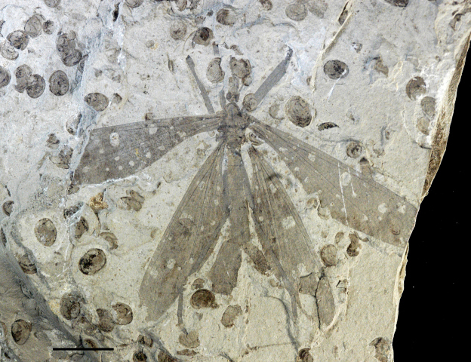
Wang, Labandeira, Shih and Ren
This ancient species of hangingflies is found in China—usually hanging beneath foliage, where they capture other insects for food. This fossil species was discovered along the preserved leaves of a gingko-like tree.

