Montgomery middle school students see their films on the big screen
By Lynh Bui,May 22, 2013
- 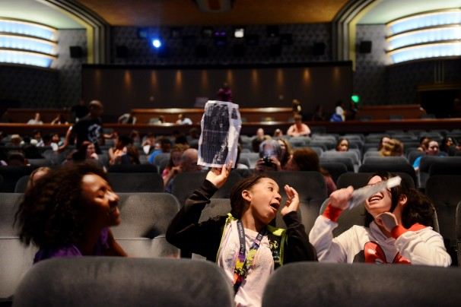
The lights lower as sixth-graders Layla White, from left, Ayana Akli and… (Amanda Voisard/For The…)
Downtown Silver Spring isn’t exactly Hollywood, but for Montgomery County middle school students, it was transformed into a scene as thrilling as any L.A. movie premiere Wednesday.
Silver Spring International Middle School students filled the seats of the AFI Silver Theatre and Cultural Center to see their documentaries and films roll on the big screen, part of a two-day film festival that continues Thursday morning. The event is the culmination of the school’s “Lights, Camera, Literacy!” classes, designed to teach middle school students about storytelling and the elements of literature through movies and other visual media.
About 50 short films screened at the festival, with beaming parents, siblings and grandparents invited to sit in the audience of the historic art-deco theater. About 350 students attended.
Marike Pinsonneault, 13, produced a three-minute movie — “The Unknown” — with other students as part of her assignment to develop a genre film. The movie is about a boy named Sean who finds himself locked in a school with a demon chasing him.
“It is just so amazing how we can have this program,” Marike said. “It helps us with our collaboration and how we work as a team in our filming groups.”
The film program started in Montgomery County in 2007, part of a $10 million middle-school reform effort. It was supposed to expand to all middle schools in the county, but funding ran out. The program will be in 19 of Montgomery’s nearly 40 middle schools next year, but the district is hoping to sell the curriculum to other schools across the country to maintain and expand the classes locally, said Arla Bowers, the program manager.
Bowers said the classes are meant to engage students who learn better through movement, visuals or sound than traditional methods of teaching. She added that the skills students learn transfer to other subjects.
“Students are taught to analyze why certain camera shots are used and to make inferences,” Bowers said. “That is the same process and thinking they have in school when they attack the written word on a page.”
On the first day of class, students are armed with video cameras and start producing projects. In the process, they learn important concepts taught in traditional English classes: conflict, character development, story arcs. Students analyze such movies as “Akeelah and the Bee” and “Searching for Bobby Fischer” in the first course. Later courses focus on the history of film, media and photography.
Lisa Melmed, a Silver Spring International teacher who instructs the classes, said the course engages students because they are learning in a hands-on environment.
“The concept of showing thoughts through moving images is more complex than just writing,” Melmed said. Students “really buy into the program because everyone likes to work with their friends . . . but it’s an environment where they were working on something that is challenging.”
Elliott Dobberstein, 13, was the lead actor in a project for Melmed’s class. He and other students created a parody of “Man vs. Wild,” a Discovery Channel show that drops explorer Bear Grylls into various isolated parts of the world to demonstrate survival methods.
In the parody, Elliott, complete with a faux accent, finds himself in a “weird and strange environment” where he has to take shelter in a “cave.” But that cave? It’s really a school.
Elliott worked with other students to write a script, develop plotlines and create characters for the movie.
“The literary aspects are a big part of it,” Elliott said. “It’s a great way to express yourself.”

