Meet Ben Kadie-Filmmaker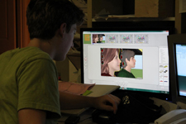
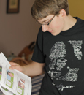15-year-old student Ben Kadie is not your average highschooler.
His films have won recognition at the Seattle International Film Festival, The Rainier Independent Film Festival, and the National Film Festival for Talented Youth.
Ben Kadie started making movies while a third grader at Seattle Country Day School. “Perilous Skies” (2007), his WWI comedy made with friend Noah Hirsch, won the Seattle Times’ Three-Minute Masterpiece Contest. Their spy comedy “009” (2008) earned an “Thomson Innovator of the Year” nomination from the National Film Festival for Talented Youth (NFFTY). “A Friendly Game” (2008), a film directed by Ben andstarring friend Dylan Forbes, was awarded a National Gold Medal from the Scholastic Art & Writing Awards (Of the 140,000 pieces of art and writing submitted, 300 earned gold medals). In 2009, Ben directed “Murder at Pharaoh’s Grave”, a mystery set in the Egypt of 1997. The Louisiana Film Festival named itbest middle school film and it won the NFFTY LA Trip Award for filmmaker potential. “Sparks in the Night”(2009), a 1940’s detective spoof directed by Ben, was named the Seattle Times Three-Minute MasterpieceGrand Prize Winner.
Slugco films have been screened at the Newport Beach Film Festival, the Chicago International Children’sFilm Festival, the Cucalorus Film Festival (North Carolina), the Sidewalk Moving Picture Festival (Alabama), the Young People’s Film & Video Festival (Oregon), the Chicago International REEL Shorts Fest, Westport (Connecticut) Youth Film Festival, and the Seattle International Film Festival.
Ben’s most popular short film, “Mack,” a Macbeth-inspired piece, just won the 2011 Scholastic Arts and Writing Regional Gold Key. The 23-minute short tells the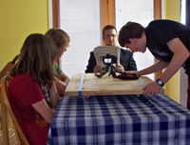story of a painter whose ambition is greater than his talent.
“Mack” began as a reinterpretation in 2010 and was refined by Kadie at TheFilmSchool’s Prodigy Film Camp. Using FrameForge 3D, he storyboarded the film to refine and perfect his plot and direction. Shot throughout Seattle, Ben used a DSLR camera, allowing for low-light capabilities.
Teachers, get ready! “Mack” has already begun showing up in the classroom to help create a deeper understanding of Shakespeare. English Teacher Jeff Youde at Quilcene High School had his students analyze characters, themes, and motifs in one scene that corresponded in the text and the film.
“Mack" will screen at da Vinci Days in Corvallis, OR, in July and the Vegas Cine Fest 2011 in August 2011.
Learn more about Ben Kadie and his films here and watch the Trailer for "Mack."

