Houses for Dreamers (and Kids)
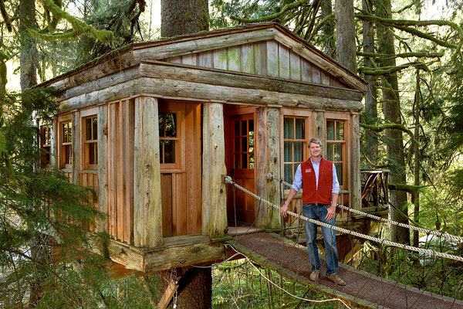
Gilles Mingasson/Animal Planet
Pete Nelson, an owner of TreeHouse Workshop, outside Seattle, with a treehouse called the Temple of the Blue Moon. More Photos »

By STEVEN KURUTZ

Published: May 29, 2013
- FACEBOOK
- TWITTER
- GOOGLE+
- SAVE
- E-MAIL
- SHARE
- PRINT
- REPRINTS
Pete Nelson, an owner of TreeHouse Workshop, outside Seattle, is an expert in his field: the design and building of treehouses. Such a distinction once guaranteed a book deal and, indeed, Mr. Nelson has written several lavishly illustrated books on the subject. But these days, being an expert at an esoteric trade more likely leads to a reality show, and on Friday “Treehouse Masters” has its premiere on Animal Planet. It follows Mr. Nelson, who is 50, and his crew as they build one over-the-top arboreal home after another.

Multimedia
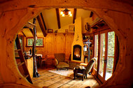Slide Show

In the Trees, Away From It All

Follow Home on Twitter
Connect with us at@NYTimesHomefor articles and slide shows on interior design and life at home.
The show unfortunately exhibits many reality-TV tropes. (When will producers quit with the quick-cut editing and ginned-up deadlines and trust that interesting people pursuing interesting passions will be interesting to viewers?) But it also has a sneaky way of reminding us, again and again, of the primordial magic of treehouses. Like when a burly man reminisces about male bonding in his family treehouse, which perches above an East Texas lake on stilts ready to collapse from rot.
Mr. Nelson is the show’s engine, a high-energy, passionate builder who is genuinely obsessed with hardwoods and softwoods alike. He recently spoke about his lofty brand of architecture.
Q. On the show you speak of trees almost worshipfully. What are your favorite species for building?
A. The Douglas fir are beautiful trees and so strong. But they’re also very convenient in that their structure is almost like a telephone pole. I love the Western red cedar trees that are out here in the Pacific Northwest. There are very few trees that are not treehouse-appropriate, although cottonwoods can be massive, and their danger is dropping major limbs. On the most calm and beautiful days, there will be a gunshot sound, and a massive limb of a cottonwood tree will fall down.
Q. Are the treehouses you design and build, some of which cost six figures, really for children?
A. I get calls all the time for kids’ treehouses. But I think the adults who are placing the calls are hiding the fact that the treehouse is for them. Some people look at these treehouse books and say, “I want one of those.” Or they’re architecture buffs. They don’t have the skills to create it, but they want it. The people who pick up the phone are dreamer types, but they’re also doer types. Somebody who’s going to spend $200,000 on a treehouse is a go-getter.
Q. Your work stretches the limits of what people may think of as a treehouse. What defines a treehouse for you?
A. My definition of a treehouse has broadened substantially. In the beginning, I thought a tree-supported structure, even a supporting post on the ground, was cheating. To me, that was a stilt house. It’s just being up in the trees that now defines a treehouse. If you want to be in a stilt house among the trees, is it a treehouse? Sure. It’s all about sharing in the energy of the tree. However you do that is fair game.
Q. You practice an ephemeral architecture. Have you ever lost a treehouse to bad weather?
A. One of the biggest we ever built was in San Diego County, and the owner lost it in the wildfires. Seven oak trees were involved, and the owner said that after the wildfire, you couldn’t fit the ashes in a bottle. It was that gone.
Q. How is the bond people develop with a treehouse different from what they feel for their home?
A. A home is a home and it’s a wonderful, warm thing. But the difference in the treehouse is that it’s a place where you are absolutely away from it all. Every one of these structures is a place to unplug and unwind. At first, I thought we’d be building backyard offices, but in 15 years I think I’ve done three. The use of these things is about reconnecting with natural worlds. STEVEN KURUTZ

