Another 20 games that make you think about life

Fans of philosophical games rejoice. We have a further 20 thought-provoking games for you to play.

Published by Tasha on 20th November 2010
First we gave you five. Then we gave you ten. Now we are giving you 20 games that make you think about life. If you have developed a taste for games of a philosophical nature, then you should be in for a treat - we have some seriously innovative games here, everything from Elude, a game that explores the nature of depression, to Ulitsa Dimitrova, a tale about a street-urchin in Russia.
As with our previous lists, we have focused mainly on free games that you can play in your browser. But we have also thrown in the occasional downloadable game. These are free to play too. Before we get to the actual games, we would like to thank all our readers who suggested titles for this list. You made our job so much easier. And, of course, kudos to the game developers who created these games. Your creativity and craft are immensely appreciated.
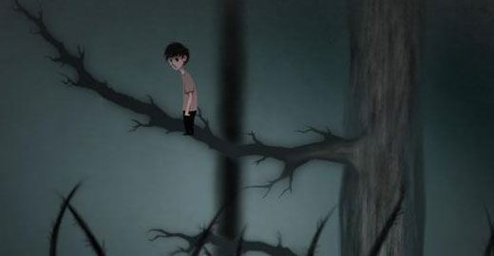
Elude

1 Elude
Developed by Singapore-MIT Gambit Game Lab, Elude is a dark, atmospheric game that aims to shed light on the nature of depression. You play a little guy exploring a beautiful yet forbidding world. The world has three distinct levels, each a metaphor for a different mental state.
The forest that you start the game in represents a normal mood. You can ascend to a higher plane - happiness - by climbing the trees in the forest. From, here you can leap joyously up into the sky by jumping on floating flowers and leaves. The leaves and flowers disappear after you have touched them and eventually none are left to keep you aloft and you plunge down into the third game area: depression.
This is a gloomy underground cavern, with a sticky muddy base that sucks you down. The first time you end up in this dark place, it is quite simple to escape, but as you progress through the game, you will end up here again and again, and each time you will find it more difficult to drag yourself out of. Elude is a mesmerising gaming experience with a serious message. Play it here.
Air Pressure

2 Air Pressure
You will have to play through Air Pressure - a Flash port of an interactive novel by Bentosmile - more than once to truly understand the characters and themes in this game. And even then you may need some time to think on it. You might, for example, simply see the game as a study of a relationship breaking down. Or, alternatively, you could argue that the girl in the game is a metaphor for some kind of addiction. Or you might... That's the beauty of the game - there is so much you can read into its multiple stories, and each person will probably draw their own unique conclusions. Play Air Pressure here.
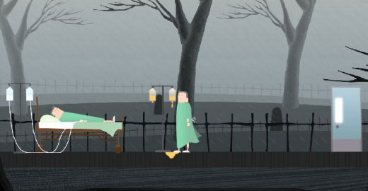
Symon

3 Symon
Another impressive production by Singapore-MIT Gambit Game Lab, Symon is a point-and-click adventure game with a difference. The game seeks to emulate the odd logic of dreams. You play a paralysed patient stuck in a hospital bed. Your only escape from this monotonous existence is to dream. As you explore your dreamscape, you rediscover repressed memories and gradually come to terms with your troubled past.
You also get to solve a lot of puzzles. But these puzzles are unlike those you find in most point-and-click games. They are designed to mimic the weird logic one experiences when dreaming. A certain amount of lateral thinking will be required to solve them. Symon is an intriguing game with a unique take on the point-and-click genre. You can play the game here.
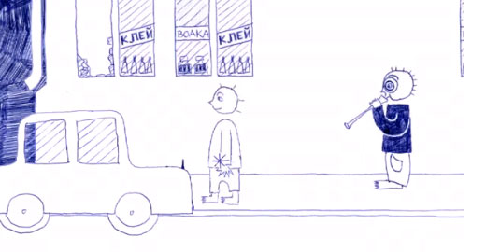
Ulitsa Dimitrova

4 Ulitsa Dimitrova
The Russians have never been the most cheery people. So one would not be too surprised to discover that a game by a Russian developer is a little on the bleak side. But even hardened melancholics might be put off by the unremittingly depressing plot of this sad game. In Ulitsa Dimitrova, you play a homeless urchin living on the streets of St Petersburg. Your mum's a prostitute. Your dad is nowhere to be seen. If that were not bad enough, you are hooked on cigarettes and will do anything to feed your habit. Try to keep alive for as long as possible. Oh, and don't think about stopping playing, because if you do something very bad will happen to your little urchin. Ulitsa Dimitrova can be downloaded here.
Ute

5 Ute
I am not quite sure what to make of this game. It is odd, sort of funny and extremely rude (if you're easily offended, don't play it). It is the kind of game you might expect from edgy Brit artist Tracey Emin (the one who did the famous bed) if she ever turned her hand to game development. On a base level, Ute is simply a reaction game where you - playing the part of an apparently sex-crazed woman - have to make love to as many men as possible in the shortest time. But the game's developer Lea Schonfelder clearly wants us to read more into the game than this. You can play the game here.
Aether

6 Aether
Game designer Edmund McMillen has an imagination to die for. He is responsible for some of the most weird and wonderful games ever created, including such masterpieces as Meat Boy - an action platformer about a chunk of meat in search of its girlfriend (recently ported to the X-Box) - and Spewer, a game in which you solve puzzles by expelling and ingesting vomit. For this list, we have chosen arguably his most thought-provoking and personal game, Aether, on which he collaborated with programmer Tyler Glaiel.
Edmund describes Aether as an "art game about personal childhood feelings and experiences". You take control of a lonely young boy and his pet monster and set out to explore the galaxy. Aether features beautiful graphics and a great story-line. It also has a unique and challenging method of moving around the game world. Play the game here.
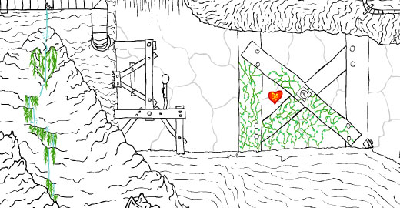
Colour my World

7 Colour my World
The Colour my... series of games by designer developer Silver Stitch are the closest you will come to poetry in game form. Featuring lovely hand-drawn artwork, tranquil music and thought-provoking dialogue, the games all involve adding colour to an initially black and white game world. As you interact with the environment and solve puzzles, you leave trails of colour behind you.
There are three games in the series - Colour My Heart, Colour My World and Colour My Dreams - and each is worth playing. If we were to choose a favourite, it would be Colour My World, which you can play here.
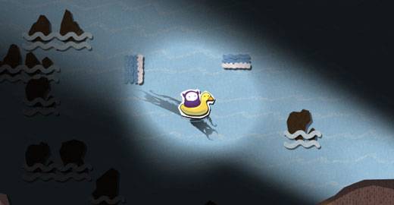
Yet One Word

8 Yet One Word
This game features one of the most interesting control mechanisms we've seen in a game. You move the game hero - a faceless horned creature - around not by using your mouse or the arrow keys but by typing in words. And not just any words either but ones that have been hand-picked to make you think.
That is not the only thing interesting about this unique platform game. Your character evolves throughout the game, but not in the usual way of defeating enemies but by the player answering personal, often uncomfortable questions. You can play Yet One Word here. The game can take some time to load but it is worth the wait.
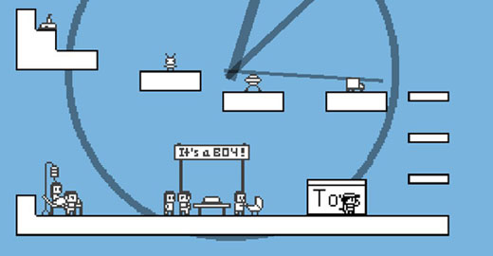
And Everything Started to Fail

9 And Everything Started to Fail
In most RPG games, you start off as a pathetically weak character barely able to support yourself on your own two legs but by the end of the game you are invariably a superman of such extraordinary powers that no-one can touch you. Life, alas, is a lot different to that - a sad fact that this game recognises. In And Everything Started to Fail, you do not simply gain skills and powers as you progress through the game, you also lose them. And eventually, you will lose them all. Clearly a metaphor for the aging process, And Everything Started to Fail can be downloaded for free here.
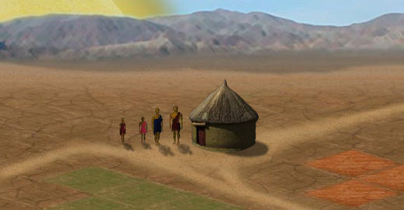
3rd World Farmer

10 3rd World Farmer
You think you have problems? Maybe you are getting stressed about exams. Or wish you could spend more time at home with your children rather than at work. Let me put your mind at rest. Those are not real problems. Real problems are when you don't know when your next meal will arrive.
Real problems are when your harvest has been stolen by bandits and you are forced to spend all the money you put aside for your daughter's education on replenishing your grain stocks. Real problems are what you experience in this game - 3rd World Farmer, a strategy game about one family's determination to escape the poverty of subsistence farming. Play the game here.
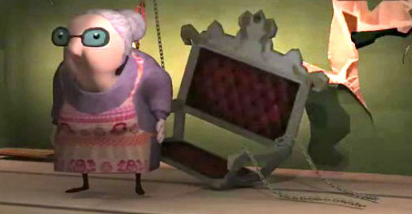
Creaky Old Memory

11 Creaky Old Memory
This beautiful online game by Denmark's National Academy of Digital Interactive Entertainment puts you in the shoes of an elderly Russian lady. To say that Tatiana's memory is not as good as it used to be is something of an understatement. She has forgotten much of her past but, with your aid, she hopes to rediscover the truth about herself. Help Tatiana reassemble an accurate picture of her life by exploring her house, finding items that help unlock snippets from her past. You can play the game here. Please note that it requires the Unity plug-in to be installed in your browser.
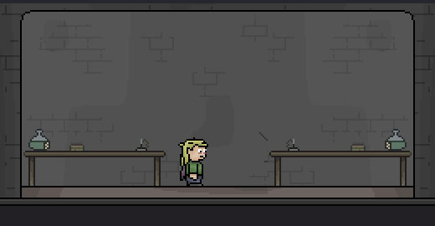
Inquisitive Dave

12 Inquisitive Dave
Inquisitive Dave - the hero of this thoughtful little adventure game - is having something of an existential moment. When you start the game, he asks why he is here, how he is going to get out and - more to the point - who is going to help him. In making us think about the predicament of the game's character, Inquisitive Dave also forces us to reflect on the nature of our own lives. Are we ourselves that much freer than the little guy that we boss around in this game. Inquisitive Dave can be played here.
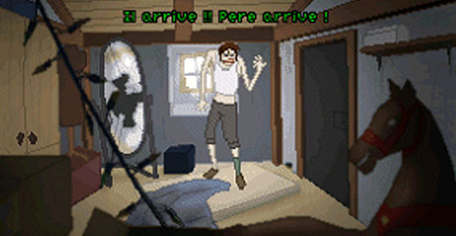
Mourir en Mer

13 Mourir en Mer
This downloadable point-and-click game by Daniel Muller might be a bit of a pain to get working with English subtitles (the game is in French by default) but the effort is worth it - Mourir en Mer is one of the most profound games we have played. It is also one of the saddest. You play a severely ill boy who has been kept locked in the attic by his father since his mother died. The poor kid does not have long to live but before he dies he wants to do one thing - see the sea for the first time. Help him escape the attic and fulfill his final wish. Mourir en Mer can be downloaded here. Instructions on how to get English subtitles can be found at the bottom of this article.
Alter Ego

14 Alter Ego
I don't know about you but my life has not gone entirely to plan. That is to say I am not in a menage a trois (kids, you don't need to know what that means) with Johnny Depp and Fernando Torres. The desert island I have always dreamed of owning is still way out of my reach. And, for the life of me, I can't beat my husband at Wii tennis. So what if I could start all over again, work harder, be better and practice a lot more Wii tennis. Oh, if only there was a way to go back... Well, thanks to this text adventure game - Alter Ego - there is, at least in a virtual sense. Alter Ego is what Second Life would have looked like if it was developed in the 1980s, only it is a lot more fun. Get you virtual personality up an running here.
Covetous

15Covetous
Given that God already frowns on the coveting of neighbourly asses (that's asses, as in donkeys, for the smutty minded biblically-ignorant crowd), I don't see the big guy in the sky having much sympathy for the protagonist in this disturbing game. This evil little fellow covets his brother's body, from the inside out.
Play it and you will know what I mean - it is actually worse than it sounds. Covetous somehow manages to be revolting, disturbing and thought-provoking all at once. Play it here.
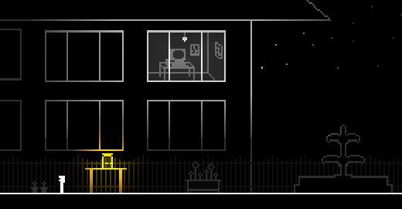
A House in California

16A House in California
Jake Elliott - who we interviewed here - was the creator of the game, I Can Hold My Breath Forever, that we placed in third position in our previous list of thought-provoking games. He is back again in this list with an intriguing point and click game themed on the idea of nostalgia - "nostalgia for childhood memories, for video games and for family," as Jake puts it. The game - A House in California - can be downloaded here.
Howard Glitch

17Howard Glitch
Howard Glitch is undoubtedly the best ever game based on youtube videos. It is also very likely the only game based on youtube videos but that minor issue should not detract from the fact that this is a truly innovative and thought-provoking game. You are trapped on a space shuttle that is controlled remotely by a pilot. Unfortunately, the pilot has fallen asleep and the shuttle is a about to crash. Do you give in and accept your inevitable death, the game asks, or do you deny reality and escape to "mount denial" - a weird parallel state of mind. Howard Glitch is a multi-layered acid trip through your subconscious. I am not sure what it means but it is pretty amazing that it was made just using youtube videos. Play the game here.
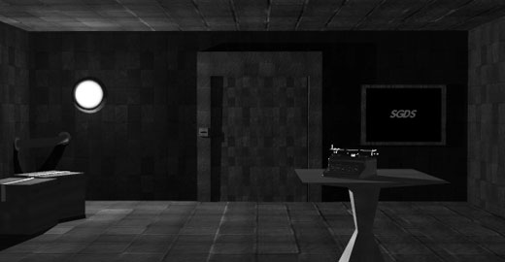
The Infinite Ocean

18The Infinite Ocean
At first sight, The Infinite Ocean looks like a petty standard escape the room game. After all, you do start off in a room and you do have to escape from it using all the point-and-clickery one has come to expect from this genre. But from this point, the game departs from the standard escape the room formula, enshrouding the reader in one of the best (and most thought-provoking) story-lines we have encountered in a online game. The dark, atmospheric graphics and evocative music also stand out from the crowd. Play this intriguing game, by Jonas Kyratzes, here.
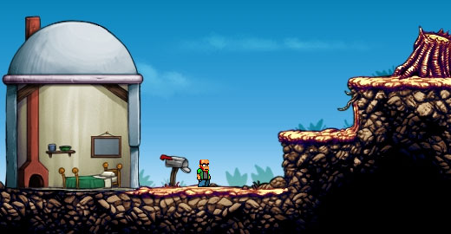
Platform

19Platform
This game gave me flashbacks to when I was an angsty teenager. In particular to the day when, after weeks of hesitation, I finally plucked up the courage to ask this guy two years above me at school on a date. He said no in a pretty nasty way, and I rushed home and cried and cried. "It's not fair, it's not fair," I wept to myself. This game is not fair. Not only is it not fair, it is mean, horrible and nasty too. But, then, life can often be like that also. So if you want a lesson in the sheer wickedness of life, by all means play Platform here.
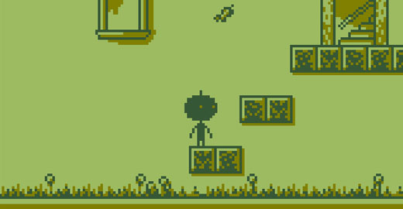
The Tower of Heaven

20The Tower of Heaven
What if God was not the all-knowing benevolent creature of Christian scripture but instead was a spiteful little git who took great pleasure in tormenting people? Well, that is a question that this game seeks to ask. You play a lone traveller in search of a revelation. Your quest for divine inspiration takes you to the Tower of Heaven, at the top of which sits one nasty deity. Think the joker from Batman fused with a European bureaucrat, and you'll have an idea of how petty and spiteful this god is. The last thing he wants is to meet one of the little guys down there, and he will do everything he can to prevent the traveller reaching the top of the tower, including changing the laws of the game. The Tower of Heaven is a neat platform game with a novel premise. Play it here.

