A Housing Solution Gone Awry
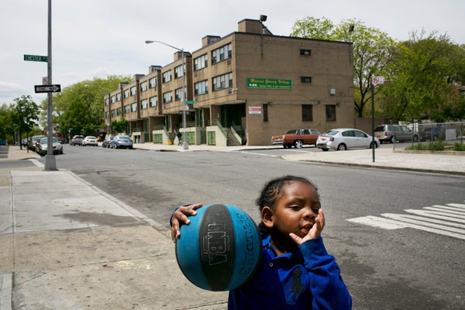
Todd Heisler/The New York Times
Jeremiah Johnson Hierro, 4, plays in Marcus Garvey Village in Brownsville, Brooklyn. His mother sends him away in the summer for his safety.

By GINIA BELLAFANTE

Published: June 1, 2013
In the early 1970s, the architect and city planner Oscar Newman came forth with a book and theory called “Defensible Space,” which relied in part on data from New York City public housing to propose a set of design solutions to the mounting problems of urban living.
EnlargeThe idealism of the ’60s extended to the notion that architecture in itself could engender meaningful social change, a belief now long out of circulation and perhaps never more so than at a time when the city’s civic leaders view development largely as bait for luring foreign capital. Mr. Newman examined public housing and determined that bigger, essentially, was worse; that taller buildings correlated with higher rates of crime and that design that was focused on giving residents a greater sense of ownership over where they lived would help prevent the delinquencies that had taken hold in the projects. The fewer the number of apartments sharing a common entry, for instance, the greater the ability for residents to both feel and exercise a sense of control over their environments.
Mr. Newman’s work brought momentum to a movement, here and abroad, for more intimately conceived apartment buildings, especially for the poor, one of the most celebrated examples of which was Marcus Garvey Village, with 625 apartments, in Brownsville, Brooklyn. Visiting Marcus Garvey today, it is nearly impossible to imagine the excitement that surrounded its groundbreaking 40 years ago, but it was born of thrilling alliances, as an exhibit at the Center for Architecture downtown, titled “Low Rise High Density,” illustrates.
In the late 1960s, Gov. Nelson A. Rockefeller initiated the short-lived Urban Development Corporation, which sought to match the best architectural talent to the creation of low- and middle-income housing. Marcus Garvey resulted from a collaboration between this agency and the Institute for Architecture and Urban Studies, an architectural research organization headed by the architect Peter Eisenman. In 1973, three years before the project was completed, the project’s design, realized by the architect Kenneth Frampton, was paid tribute with an exhibition at the Museum of Modern Art. The buildings themselves resembled student co-ops on progressive college campuses. Apartment doors opened to the outside rather than onto hallways; the units had communal mews and private backyards. And yet, ultimately, the distinguishing elements delivered consequences radically different from the grand intentions.
The fate of Marcus Garvey Village is not addressed in the Center for Architecture’s show, but the sense of exuberant experimentation that attended the project could not insulate it from the problems of poverty that have troubled Brownsville for decades. As one former official at the city’s Department of Housing Preservation and Development told me, Marcus Garvey actually makes the ailing towers of the Housing Authority so heavily concentrated in Brownsville “look good.”
About 10 years ago, Susan Saegert, a professor of environmental psychology at the City University of New York and two doctoral students looked at life in the structures and found that the courtyard areas, a hallmark of the design, became a nexus of the drug trade in the ’80s and ’90s precisely because they were shielded from public access and view. What was meant to foster an elevated sense of privacy instead contributed to criminality.
Marcus Garvey turned into a home base for the Folk Nation gang. A decade ago, the complex became the target of a joint operation by the Police Department and the Federal Bureau of Investigation to combat the problem of drug- and gang-related violence in the residences. Since the construction of Marcus Garvey, the poverty rate in Brownsville has not gone down; it has gone up — to close to 40 percent today from 29 percent in 1970. As Professor Saegert wrote in her analysis, “Development does not end when developments open. This is when the real work begins.” Mindful design can accomplish little divorced from broad, aggressive strategies to fight social inequality.
The most dispiriting irony about life in Marcus Garvey Village today is that its residents could not possess less of a sense of control over where they live. Crime has abated but a heavy and oppressive police presence has not, residents told me. Marcus Garvey Village is patrolled by a private security force as well. When I visited several weeks ago with a colleague, guards insisted on following us and tried to claim, inexplicably, that we could not talk to residents on their stoops or in their apartments even if we were invited in.
One resident, Jamal Matherson, told of seeing a friend pinned down one evening a few weeks ago by three police officers for no obvious reason when they were talking outside their building. Another resident talked about seeing a little girl on a stoop approached by a police officer who checked her drink to make sure it did not contain alcohol (she was having iced tea). If you happen to be having a glass of wine on your stoop in Cobble Hill, the chances that a police officer will tell you to stop are roughly equal to the chance that a schnauzer will pass on an excellent stock tip. If you are drinking wine on the stoops of Marcus Garvey Village you will most likely be questioned and given a ticket.
Stoops, in the Jane Jacobs sense, are supposed to inspire communality; here they inspire more surveillance. Mews are rarely used anymore, one young mother, Shelecia Johnson, told me. Barbecues rarely happen. Ms. Johnson has a 4-year-old son; in the summer when things are both dull and more dangerous, she sends him away. Soon, he will be headed to the Carolinas.

