35 Powerful Photos That Tell A Story
- By Aquil Akhter
- Posted in Photography
“A picture is worth a thousand words.” That is the motto of a photojournalist. It is their objective to produce direct, truthful and bold images that tell the stories for those who have no voice.
According to Mark M. Hancock, a professional photojournalist, “is a visual reporter of facts. The public places trust in its reporters to tell the truth. The same trust is extended to photojournalists as visual reporters.This responsibility is paramount to a photojournalist. At all times, we have many thousands of people seeing through our eyes and expecting to see the truth. Most people immediately understand an image.”
Photojournalists are doing really a great job over the world for humanity, they are working for peace, for human rights, for raising humanity problems and issues, for pointing out the people living below the bottom line of poverty, for raising awareness about educational and child labor issues and much more… Our today’s post is about Inspirational Documentary and Photojournalism Photos. In this post we showcase 35 powerful, touching and emotional photos that do not just display state of affairs, but also tell a story.
We express sincere appreciation of the hard work of all photojournalists who are working for humanity, sometimes risking their life for the sake of their duties and responsibilities. This article is a tribute to all of them and their accomplishments and works.

Photojournalism & Documentary Photos
Man mutilated Rwanda
World Press Photo of the Year: 1994 James Nachtwey, USA, Magnum Photos for Time. Rwanda, June 1994. Hutu man mutilated by the Hutu ‘Interahamwe’ militia, who suspected him of sympathizing with the Tutsi rebels. About the image Nachtwey says his specialty is dealing with ground level realities with a human dimension. He feels that people need photography to help them understand what’s going on in the world, and believes that pictures can have a great influence on shaping public opinion and mobilizing protest.
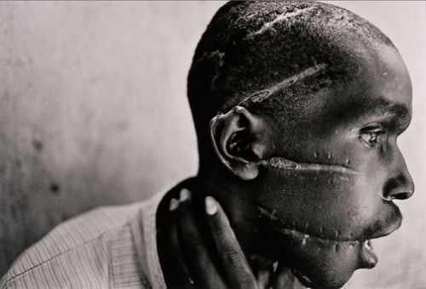
Losing
In this picture, Lurlena cries in the back of the family car after losing the contest for Carnival Princess at her school. She spent the day getting ready, with a new white dress and new shoes. The winner was decided based on whose parents bought the most tickets, and Lurlena’s family could only afford eight dollars worth.

Hard Work in Hong Kong
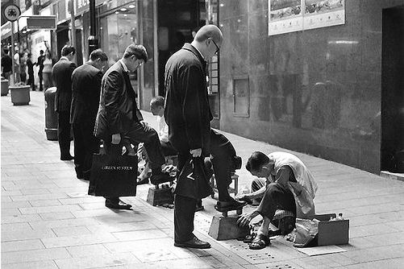
tbaur
Sally Mann
This photo, titled Candy Cigarette, not just displays something, it tells a story. It is both emotional and beautiful. This is what the originality of black-and-white-photography is all about.
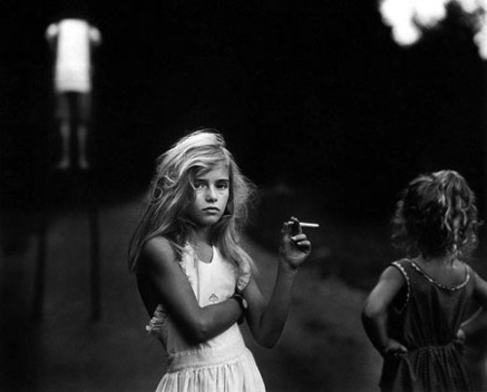
Pilgrim
Tibetans believe, once in their life, a pilgrimage to Lhasa is of exalted purpose and moral significance. Therefore, we see people like this, especially in spring and autumn, on their journey of faith, sometimes thousands of miles long, kowtowing every few steps.
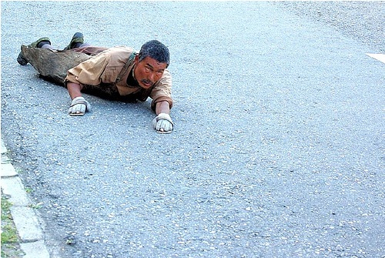
Arirang Mass Games
Even during the Arirang Mass Games in North Korea, the ultimate expression of the state ideology, an individual can still sometimes stand out from the crowd and break free of the collective. If only just for a moment. (Photo and caption by Brendyn Zachary)
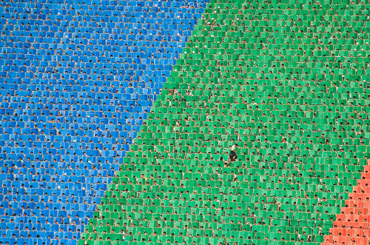
Iguazu falls in Brazil
“On my second day visiting the astounding Iguazu falls on the Brazilian side I was forced to change to my telephoto lens as my wide angle had been damaged by the water vapour. In had rained solid for 10 days prior to my arrival and so the falls were at their most spectacular. Standing on the elevated viewing platform I was able to shoot this school group who stood transfixed, emphasizing the incredible size of the falls. (Photo and caption by Ian Kelsall)”
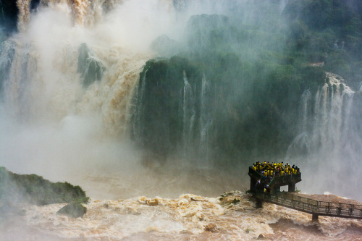
Malawian boy running after 4×4
“I took the photo while on my one-month stint in Malawi Africa where I mainly worked in orphan day-care centres, also visiting Mulanji Hospital. The photo was taken from the Mulanji Hospital four-wheel-drive ambulance, travelling on the extremely rough roads from village to village, visiting the sick who were unable to reach the hospital.” Photo taken by Cameron Herweynen.
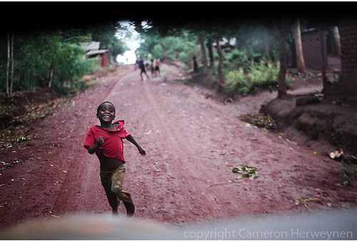
Sewing Machine
A damaged sewing machine after the cyclone hit, Amtali, Patuakhali, Bangladesh 19 November 2007. EPA/ABIR ABDULLAH
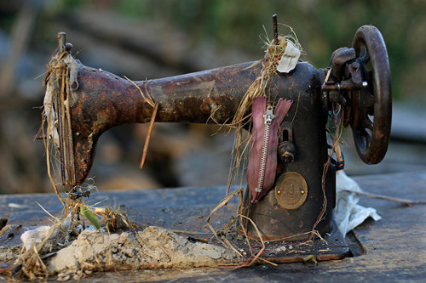
Shelter
Child takes shelter with his mother before the cyclone hit. Cox’s Bazar, Bangladesh.
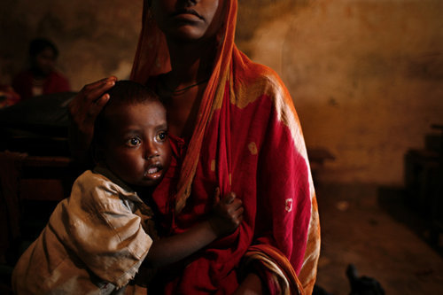
New Year’s Eve, St. Jacques, Perpignan, 2006
This picture of a five year-old gypsy boy was taken on New Year’s Eve 2006 in the gypsy community of St. Jacques, Perpignan, Southern France. For Christmas and New Year’s Eve, the men would gather in the Café in their best suits to drink and dance while their wives would prepare dinner at home. It is quite common in St. Jacques for little boys to smoke.
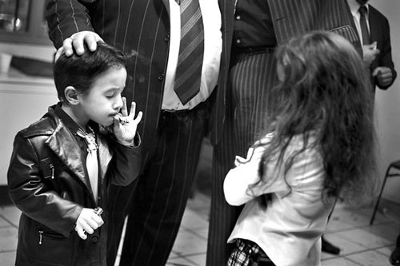
Riot in the city
Riot in Toulouse, France (March 25th, 2007) after the campaign of a politician.
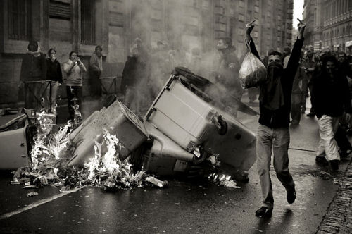
Jump!
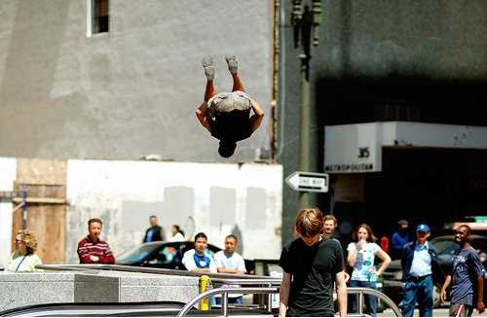
Pain and Beauty
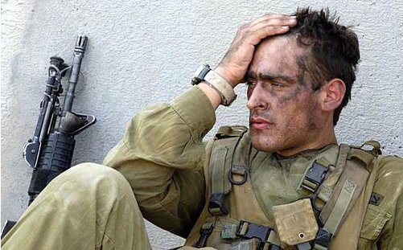
Bhopal Disaster
This photograph from December 4, 1984 shows victims who lost their sight in the Bhopal poison gas tragedy as they sit outside the Union Carbide factory in Bhopal, India.
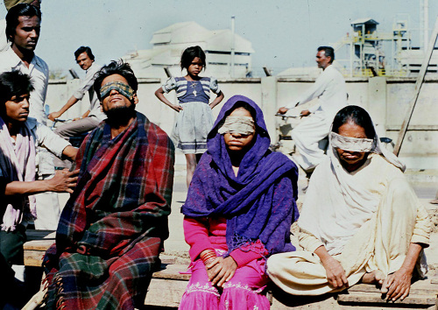
From the series “Children of Black Dust”, Dhaka, Bangladesh
A woman holds her child, blackened by carbon dust. His nose bleeds due to infections caused by exposure to dust and pollution during play in the workshop in Korar Ghat by on the outskirts of Dhaka. Many women bring their children along so they can look after them while working.
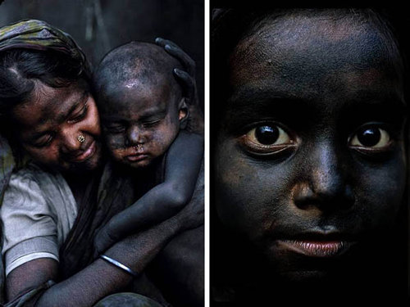
New York City
USA. New York City. September 15, 2001. Signing a memorial in Union Square.
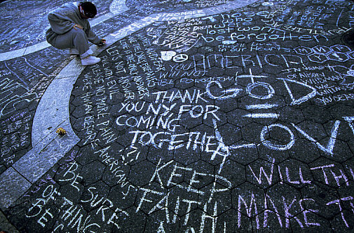
Hhaing The Yu
Hhaing The Yu, 29, holds his face in his hand as rain falls on the decimated remains of his home in the Swhe Pyi Tha township, near Myanmar’s capital of Yangon (Rangoon), on Sunday, May 11th, 2008. Cyclone Nargis struck southern Myanmar a week ago leaving millions homeless and has claimed up to 100,000 lives.
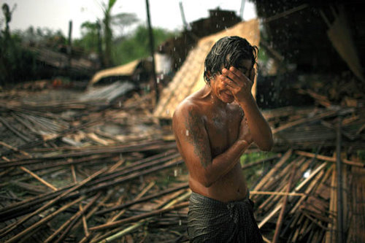
Culture
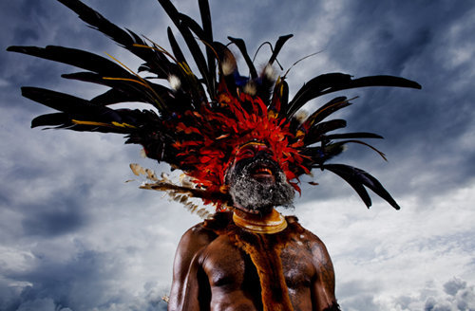
Sandra Gil
A long line of visitors forms in front of Sandra Gil outside the Krome Detention Center in Miami where her husband, Oscar Gonzalez, is being held. On the morning of November 8, Immigration and Customs Enforecment (ICE) officers arrested the family at their home. They detained Gonzalez and released Gil with her son, American born Joshua Gonzalez, 5, with orders to leave for Colombia within weeks, The family was denied asylum after seven years living and working legally in teh country.
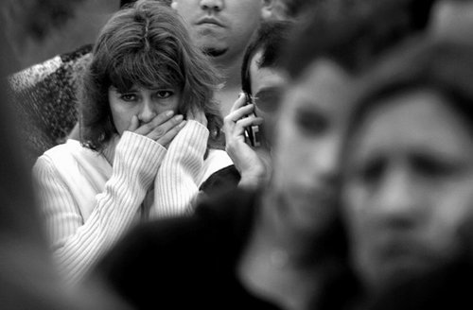
Memories
Sitting alone on a little place surrounded by cars traffic. Self-isolation. Waiting for nothing. He talked to me for about an hour. Of a lost life. An ordinary life like mine, like many others. And now…
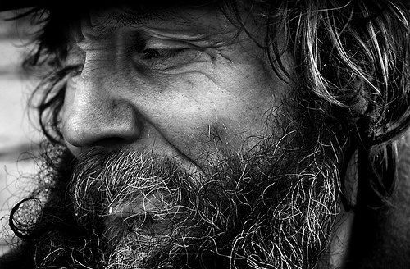
Tap-Tap
Tap-tap buses waiting to get full and depart for their regular route in the downtown of Port-au-Prince.
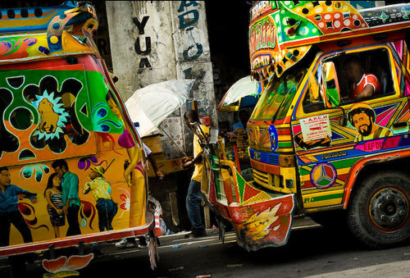
Swiss pilot Yves Rossy
Swiss pilot Yves Rossy, the world’s first man to fly with a jet-powered fixed-wing apparatus strapped to his back, flies during his first official demonstration, on May 14, 2008 above Bex, Switzerland. (Fabrice Coffrini/AFP/Getty Images)
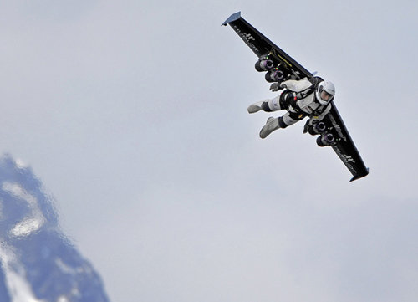
María A.C. (ernieland)
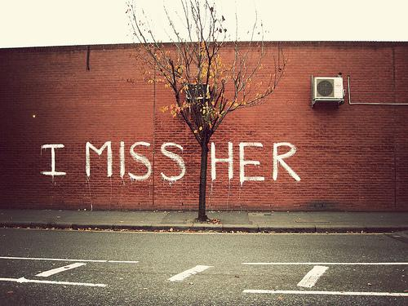
Unknown
Gold Price
In Wall street, a man holds a placard of ” We Buy Gold”, as gold price has increased due to the current financial crisis or economic melt-down.
New York, Oct 13 2008.
Child Labor In Egypt
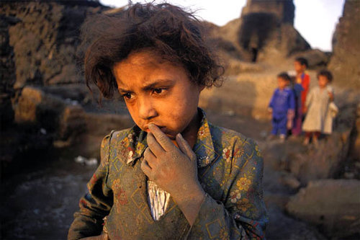
Construction worker, Soweto Township
Final construction at the Maponya mall in Piville township, Soweto. The 650 million Rand mall is one of the largest shopping centers in South Africa, and its opening is a sign of the commercial awakening of Soweto.
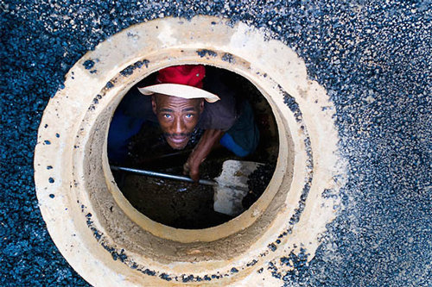
Child Labor. Bangladesh
Child labor is not a new issue in Bangladesh as children here remain one of the most vulnerable groups living under threats of hunger, illiteracy, displacement, exploitation, trafficking, physical and mental abuse. Although the issue of child labor has always been discussed, there is hardly any remarkable progress even in terms of mitigation. 17.5 percent of children aged 5-15 are engaged in economic activities. Many of these children are engaged in various hazardous occupations in factories.
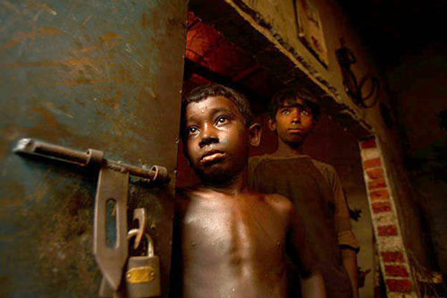
Aftermath of Earthquake in Balakot, Pakistan. 2005
This image was taken about one month after the earthquake in Pakistan. People were still coming down from the mountains trying to find shelter and were suffering from trauma. Winter was on the way and the need for shelter was urgent. This father with his child had been collecting food. I spent ten days in Balakot documenting the situation after the quake. People were still digging for their family members.
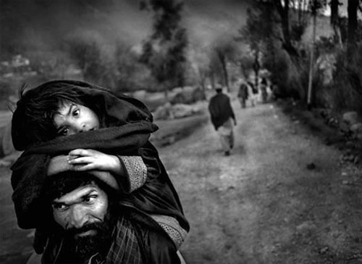
Seen in Ludwigsburg, Germany
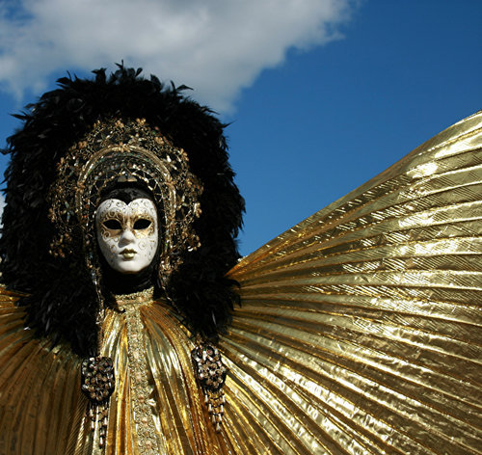
Huge Wave
Kerby Brown rides a huge wave in an undisclosed location southwest of Western Australia July 6, 2008, in this picture released November 7, 2008 by the Oakley-Surfing Life Big Wave Awards in Sydney. Picture taken July 6. (REUTERS/Andrew Buckley)
The Head of a Male Student
The head of a male student, still alive, trapped under the debris is pictured at the scene of the church school that collapsed on the outskirts of Haiti’s capital Port-au-Prince, November 7, 2008. At least 30 people were killed when the three-story La Promesse school building collapsed while class was in session and some of the walls and debris crushed neighboring homes in the Nerettes community near Port-au-Prince. (REUTERS/Joseph Guyler Delva)
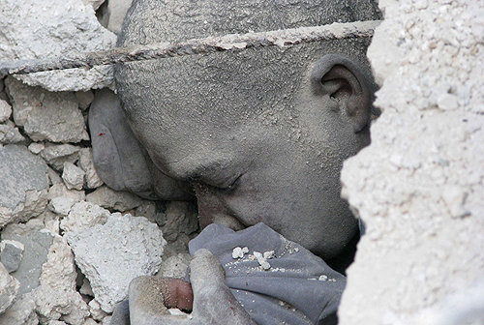
Starving Boy and Missionary
Wells felt indignant that the same publication that sat on his picture for five months without publishing it, while people were dying, entered it into a competition. He was embarrassed to win as he never entered the competition himself, and was against winning prizes with pictures of people starving to death. (World Press Photo of the Year: 1980 Mike Wells, United Kingdom. Karamoja district, Uganda, April 1980).
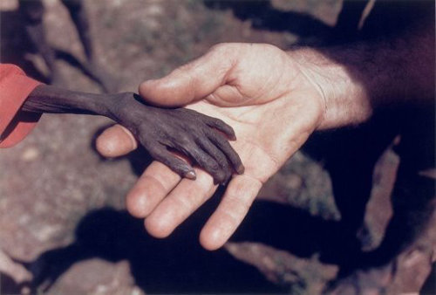
Afghan Girl
And of course the afghan girl, picture shot by National Geographic photographer Steve McCurry. Sharbat Gula was one of the students in an informal school within the refugee camp; McCurry, rarely given the opportunity to photograph Afghan women, seized the opportunity and captured her image. She was approximately 12 years old at the time. She made it on the cover of National Geographic next year, and her identity was discovered in 1992.
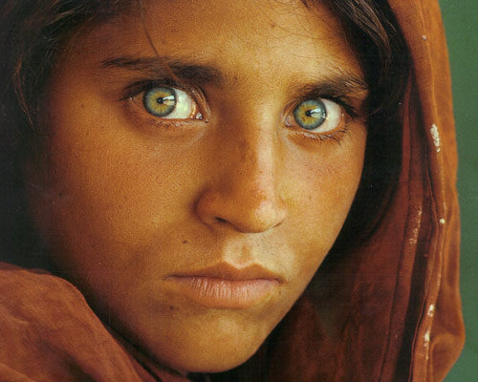
Sichuan Earthquake
A man is crying while he flips through a family album he found in the rubbles of his old house.
